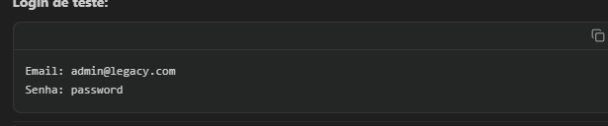

Email: admin@legacy.com
Senha: password

npx ts-node src/server.ts

npm run dev

